Basic Network Sniffer Using Python
NAME: Deepika .R
DOMAIN: Cyber Security

INTRODUCTION
A Network Sniffer is a tool used to capture and monitor data packets traveling through a network. It helps analyze network communication, troubleshoot network issues, and understand how devices exchange data. This project uses Python and the Scapy library to capture live packets and display important packet information.

OBJECTIVE
- Capture live network packets.
- Display Source IP and Destination IP.
- Identify the protocol used.
- Understand the basics of packet sniffing.

TOOLS USED
- Python 3
- Scapy
- Npcap
- IDLE Python
- Windows Operating System

PROGRAM CODE

from scapy.all import *
def packet_callback(packet):
print("\n=== Packet Captured ===")
if packet.haslayer(IP):
print("Source IP:", packet[IP].src)
print("Destination IP:", packet[IP].dst)
print("Protocol:", packet[IP].proto)
print(packet.summary())
print("Starting Network Sniffer...")
print("Press Ctrl + C to stop.\n")
sniff(prn=packet_callback, store=False)
input("Press Enter to exit...")

OUTPUT
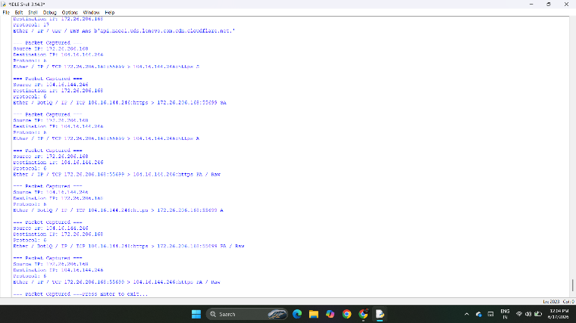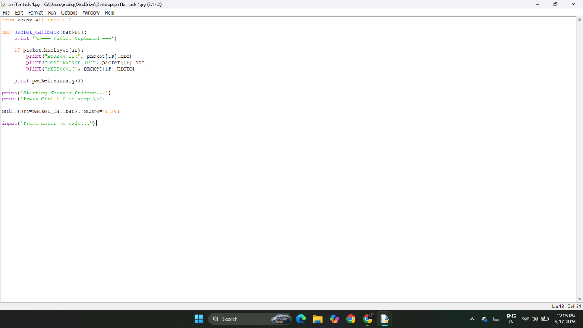
FEATURES
- Captures live network packets.
- Displays Source and Destination IP addresses.
- Shows protocol information.
- Displays packet summary.
- Runs continuously until stopped.

ADVANTAGES
- Easy to implement.
- Helps in network monitoring.
- Useful for cybersecurity learning.
- Lightweight and efficient.

APPLICATIONS
- Network Monitoring
- Packet Analysis
- Cybersecurity Training
- Network Troubleshooting
- Educational Projects
CONCLUSION
The Basic Network Sniffer was successfully implemented using Python and the Scapy library. The program captured live network packets and displayed essential information such as Source IP Address, Destination IP Address, Protocol Number, and Packet Summary. This project enhanced the understanding of network communication, packet analysis, and basic cybersecurity concepts.

